Application No: 2300163-RMASUB
For: 184 Koutu Loop Road, Whirinaki 0473

22 September 2020

Darius Cleaver and Pearl Yvonne Cleaver
C/- Thomson Survey Ltd Att: Denis
PO Box 372
Kerikeri 0245

Dear Darius and Pearl Cleaver,

Acknowledgement of Receipt of Subdivision Application

Thank you for your application for a proposed subdivision, potential right of way and boundary adjustment at 184 Koutu Loop Road, Whirinaki. Your application was lodged on 21 September 2020 and your application reference number is 2300163-RMASUB. The application has been assigned to me for processing. Should I require further information I will contact you within 20 working days.

Your feedback is important to us, so after a decision has been issued, we will be sending you a brief questionnaire to assist us with improving our customer service. As council charges the actual and reasonable costs of consent processing, you may be sent either an invoice or a credit note.

Please note that due to high volumes, some applications are unable to be processed within statutory timeframes.

If you have any questions about your application, please contact me on 0800 920 029 or email Hannah.Kane@fndc.govt.nz
.

Yours sincerely,

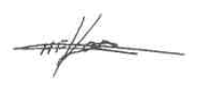

Hannah Kane
Resource Planner

Resource Consents Department

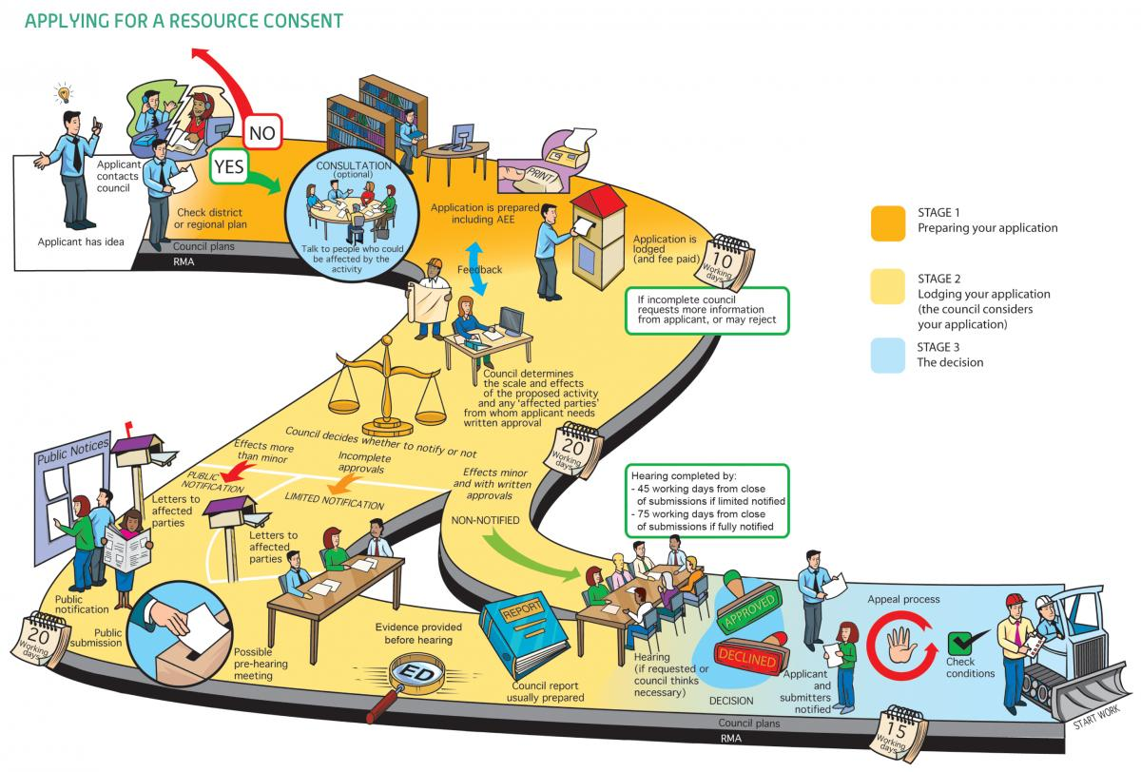Image 1: Image from "An Everyday Guide to the RMA: Applying for Resource Consent" - Ministry For the Environment, 2015

