26 June 2020

Michelle French
C/- Totalspan Bay of Islands/Hokianga
1235B Bulls Road
RD 3
Kerikeri 0293

Dear Sir/Madam

Building consent number: | EBC-2020-12022/0
Property ID: | 3361107
Address: | Lot 7, Waianga Place, Omapere 0473
Description: | Proposed Lot 8 - Unlined Heritage Barn

I am writing in relation to EBC-2020-12022/0, which was originally issued with a Form 4 in relation to the need for a Resource Consent prior to work on your project commencing.

Further to discussions and amended plans and associated documentation received from Totalspan Bay of Islands/Hokianga, this letter is to confirm that Resource Consent is no longer required for the above project.

Our records have been updated accordingly.

Yours faithfully
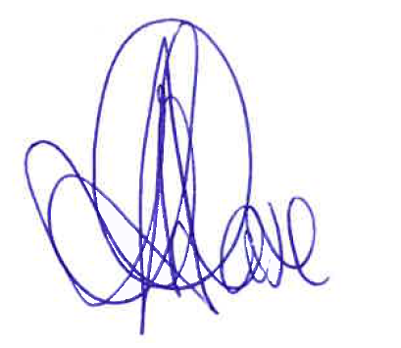
Aroha Chase
PIM Officer
District Services

