Property ID: 3361107

21 May 2020

Michelle French
C/- Totalspan Bay of Islands/Hokianga
1235B Bulls Road
RD 3
Kerikeri 0293

Dear Sir / Madam,

Building consent number: | EBC-2020-12022/0
Property ID: | 3361107
Address: | Lot 7, Waianga Place, Omapere 0473
Description: | Proposed Lot 8 - Unlined Heritage Barn

Requirement for Resource Consent

PIM Assessment of your application has highlighted the need for Resource Consent that must be granted prior to any building works or earthworks commencing.

The site is zoned Coastal Residential under the District Plan and Resource Consent is required for breach of the following:

 | Variation Condition 1 of RC2200170 as it relates to Consent Notice (i) and (iii)
Reason: | Geotech Report has not been provided with this application and the Site Suitability Report provided does not address foundations. The proposed stormwater disposal does not specify that there will be a stormwater detention system at least 15000 litres in size and the discharge/overflow from the tank is not directed to the swale drain along the right of way as required by the site suitability report.

Please note there may be other rule breaches found during the Resource Consent process. It is your responsibility to ensure the Resource Consent approved plans match the Consented approved plans.

The application form can be downloaded from www.fndc.govt.nz and submitted to Council’s (Planning Department) with the appropriate documentation and instalment fee.

If you have any queries please contact the Duty Planner on Duty.Planner@fndc.govt.nz or 0800 920 029.

Yours faithfully
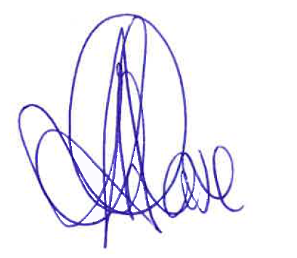

Aroha Chase

PIM Officer
District Services

Property ID: 3361107

FORM 4
Certificate attached to
PROJECT INFORMATION MEMORANDUM
Section 37, Building Act 2004

Building Consent Number: EBC-2020-12022/0

RESTRICTIONS ON COMMENCING BUILDING WORK UNDER
RESOURCE MANAGEMENT ACT 1991
 | The building work referred to in the attached Project Information Memorandum is also required to have the following Resource Consent(s) under the Resource Management Act 1991:
- Resource Consent – REQUIRED

As the above Resource Consent(s) will affect the building work to which the Project Information Memorandum relates, until this has been granted no building work may proceed.

Failure to comply with the requirements of this notice may result in legal action being taken against you under the Resource Management Act 1991.

 |  | 
Signature:
 |  | Dr Dean Myburgh
Position: |  | General Manager District Services
On behalf of: |  | Far North District Council (Building Consent Authority)
Date: |  | 21 May 2020

