Application No: 2300163-RMASUB

26 January 2021

Darius Cleaver and Pearl Yvonne Cleaver
C/- Thomson Survey Ltd Att: Denis
PO Box 372
Kerikeri 0245

Dear Sir / Madam,

Re: RESOURCE CONSENT APPLICATION BY Darius Cleaver and Pearl Williams

I am pleased to inform you that your application for resource consent has been approved. The decision is enclosed for your information. The application was considered and determined under authority delegated to the Team Leader Resource Consents of the Far North District Council, pursuant to Section 34A of the Resource Management Act 1991.

It is very important that you understand and comply with any conditions of consent. If you have any questions or concerns about any aspect of your consent or its conditions, please contact the planner who prepared the decision.

Please note, that you will be sent either an invoice or credit note depending on the actual cost of processing your application. Any additional costs shown on an invoice need to be paid by the 20th of the month following the date of the invoice. If you receive a credit note, you have the option of requesting a refund by bank transfer, or transferring the amount to any other Council account. Please advise and supply a printed bank deposit slip and allow 10 working days for the refund to be processed.

If you have any further queries regarding this matter, please contact the reporting Planner.

Yours faithfully

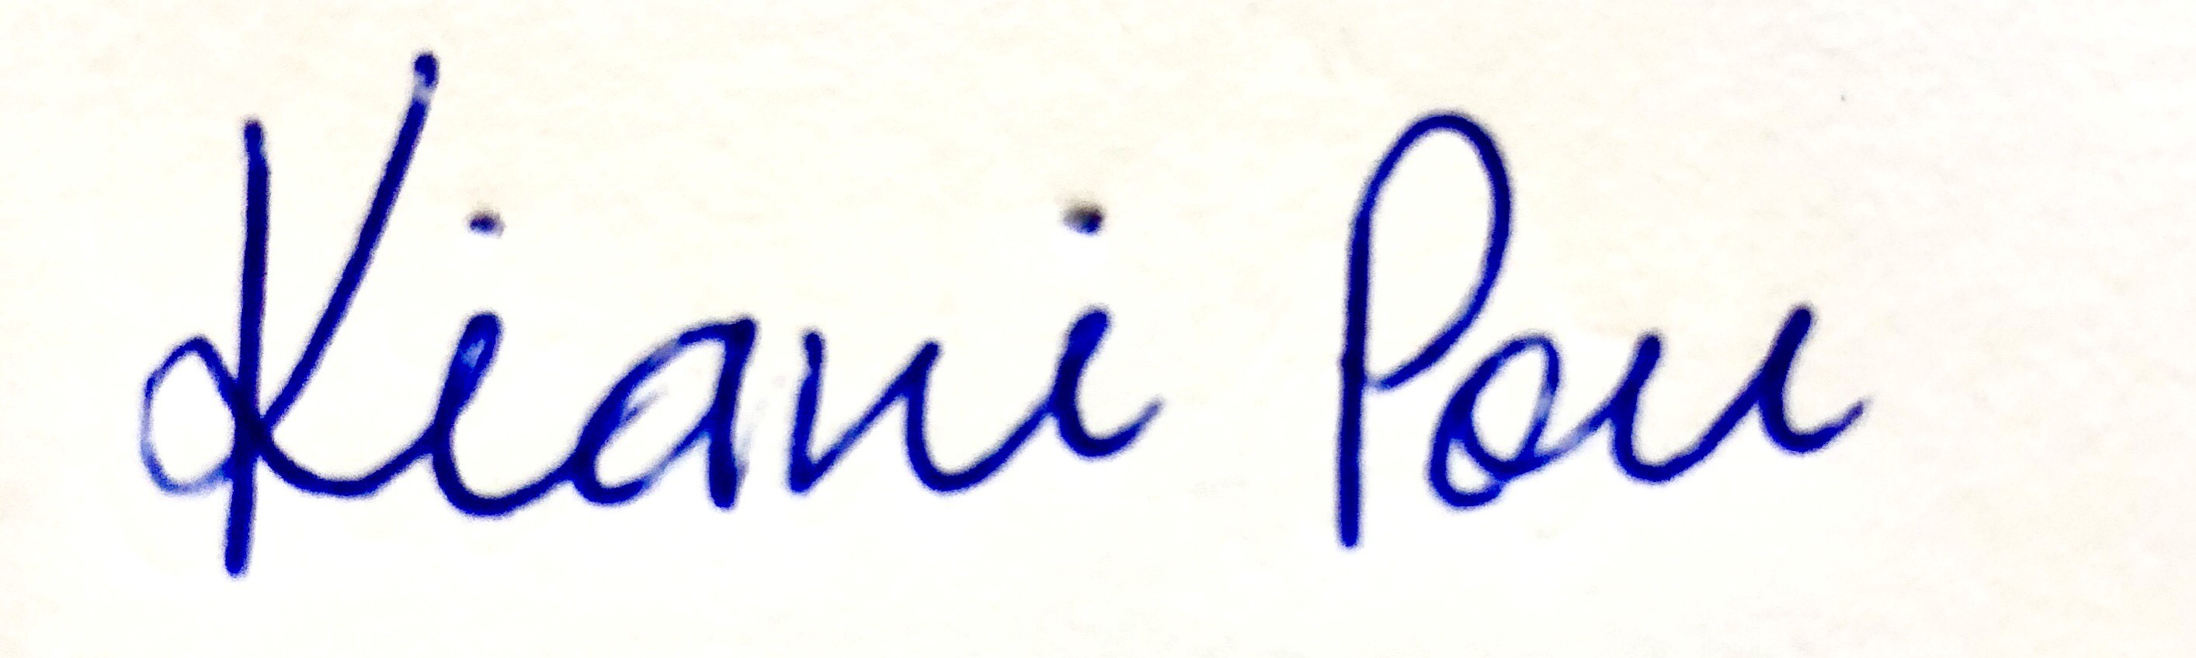

Kiani Pou
Planning Support
Resource Consents Department

