Application No: 2200253-RMASUB
For: Lot 2, Newton Road, Omapere 0473

11 November 2019

Zhann Tracey
C/- Thomson Survey Ltd
PO Box 372
Kerikeri 0245

Dear Zhann Tracey,

Acknowledgement of Receipt of Subdivision Application

Thank you for your application to Propose subdivision to create 4 additional lots. at Lot 2, Newton Road, Omapere 0473. Your application was lodged on 6 November 2019. Your application reference number is 2200253-RMASUB. The application has been assigned to me for processing. Should I require further information I will contact you within 20 working days.

Your feedback is important to us, so after a decision has been issued we will be sending you a brief questionnaire to assist us with improving our customer service. As council charges the actual and reasonable costs of consent processing, you may be sent either an invoice or a credit note.

Please note that due to high volumes, some applications are unable to be processed within statutory timeframes.

If you have any questions about your application please contact me on 0800 920 029 or email alvin.j@stellarprojects.co.nz
.

Yours sincerely,

Sequoia Stevens
Alvin Jung

Resource Consents Department

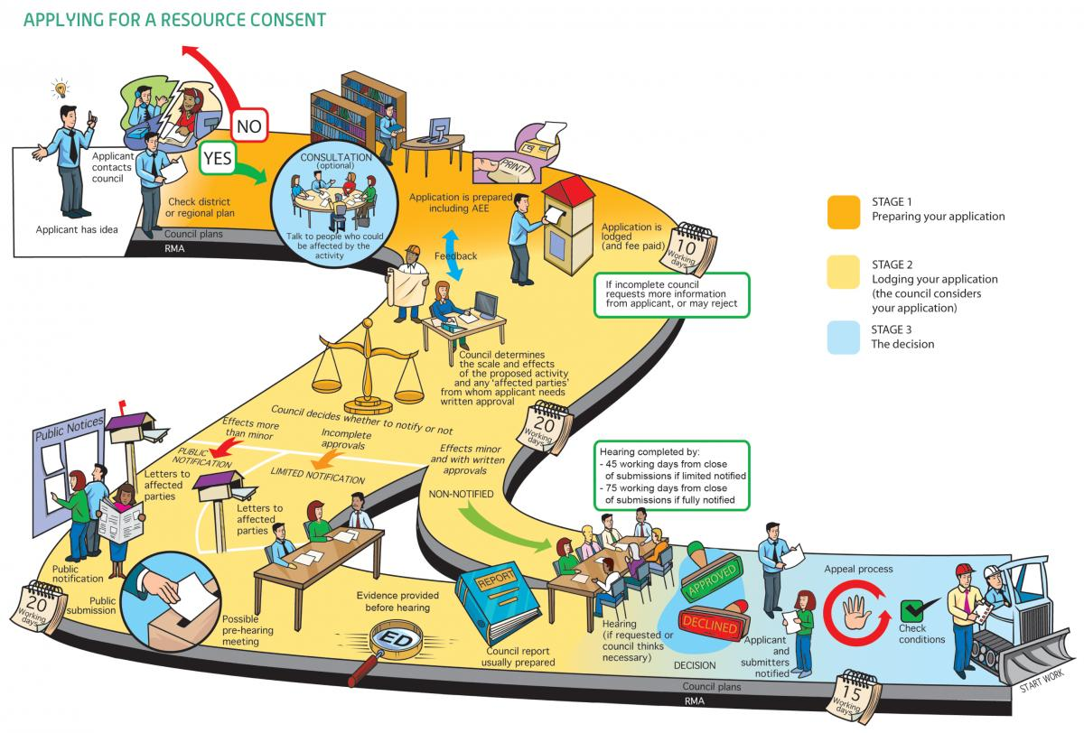Image 1: Image from "An Everyday Guide to the RMA: Applying for Resource Consent" - Ministry For the Environment, 2015

