22 May 2018

Haydn Paul Hutching and Mary Florence Hutching
8121 State Highway 12
RD 3
Kaikohe 0473

Building consent number: | BC-2017-1287/1
Property ID: | 3328267
Address: | 8121 State Highway 12, Kaikohe 0473
Description: | Install a Freestanding Fire

Dear Sir / Madam

Issue of Code Compliance Certificate (CCC)

Congratulations on successfully completing your building project.

A Code Compliance Certificate (CCC) has now been issued for your new building.

This brings the consent process to its conclusion and your property files have been updated accordingly.

Thank you for choosing to build in the Far North.

Yours sincerely,
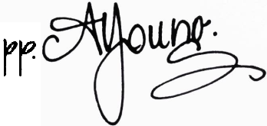
Building Team
District Services

