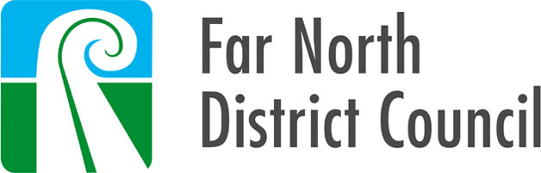

4 July 2019

Brendan Nichols and Jill Kathleen Nichols and Nicholbee Trust Company Limited
Counter Delivery
Waimamaku PostCentre
Waimamaku 0446

Building consent number: | BC-2016-617/1
Property ID: | 3328410
Address: | 7849 State Highway 12, Waimamaku 0473
Description: | Construct MiTek Lean-To Farm Building

Dear Sir / Madam

Issue of Code Compliance Certificate (CCC)

Congratulations on successfully completing your building project.

A Code Compliance Certificate (CCC) has now been issued for your new building.

This brings the consent process to its conclusion and your property files have been updated accordingly.

Thank you for choosing to build in the Far North.

Yours sincerely,
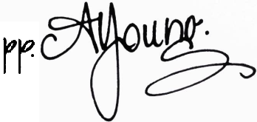
Building Team
District Services

Property ID: 3328410

FORM 7
CODE COMPLIANCE CERTIFICATE
Section 95, Building Act 2004

Building Consent Number: BC-2016-617/1
THE BUILDING
 | Street Address of Building: |  |  |  | Legal description of land where building is located:
 | 7849 State Highway 12, Waimamaku 0473 |  |  |  | LOT 1 DP 184898
 | Building Name: |  | Level/Unit Number: |  |  |  | Current, lawfully established, use:
 |  |  |  |  |  |  | 7.0.1 Outbuildings
 | Location of Building within site / block number: |  |  |  | Year first constructed:
 |  |  |  |  | 2018
THE OWNER
 | Name of Owner: |  |  |  | Contact Person Name:
 | Brendan Nichols and Jill Kathleen Nichols and Nicholbee Trust Company Limited
 | Mailing Address:
 | Counter Delivery, Waimamaku PostCentre, Waimamaku 0446
 | Street Address / Registered Office:
 | As Above
 | Phone Number: |  | Landline: |  |  |  | Mobile:
 | Daytime: |  | After Hours: |  |  |  | Facsimile Number:
 | Email Address: |  |  |  | Website:
First point of contact for communications with the building consent authority:
 | Far North District Council |  | Freephone: 0800 920029
 | Memorial Avenue |  | Phone: (09) 401 5200
 | Private Bag 752 |  | Fax: (09) 401 2137
 | Kaikohe 0440 |  | Email: ask.us@fndc.govt.nz
 | New Zealand |  | Website: www.fndc.govt.nz
BUILDING WORK
 | The following building work is authorised and issued by Far North District Council:
 | Construct MiTek Lean-To Farm Building
CODE COMPLIANCE
 | The building consent authority named below is satisfied, on reasonable grounds that the building work complies with the building consent.
 |  | 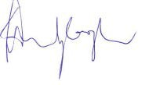
Signature:
 |  | Dr Dean Myburgh
Position: |  | General Manager, District Services
On behalf of: |  | Far North District Council (Building Consent Authority)
Date: |  | 4 July 2019

