DETERMINATION AS TO WHETHER A RESOURCE CONSENT APPLICATION SHOULD BE NOTIFIED OR NON NOTIFIED UNDER SECTIONS 95A, 95B & 95C, OF THE RESOURCE MANAGEMENT ACT 1991

1. Application details
Council Reference: | 2051100-RMAVAR/B
Reporting Planner: | Esther-Amy Powell
Applicant: | Elaine Sun
Description of Application: | To cancel consent notice CONO7056308.3 insofar as it applies to CT-273757, CT-273760, CT-273761, CT-273762, CT-273764, CT-273772, CT-273773, CT-273781, CT-298403, CT-298404, CT-298408, CT-298409, CT-298412.
Property Address: | 30 Opononi Heights Drive, Opononi  36 Opononi Heights Drive, Opononi  38 Opononi Heights Drive, Opononi  40 Opononi Heights Drive, Opononi  44 Opononi Heights Drive, Opononi  27 Opononi Heights Drive, Opononi  29 Opononi Heights Drive, Opononi  35 Opononi Heights Drive, Opononi  51 Opononi Heights Drive, Opononi  53 Opononi Heights Drive, Opononi  61 Opononi Heights Drive, Opononi  63 Opononi Heights Drive, Opononi
Legal Description: | Lot 15 DP 367355  Lot 18 DP 367355  Lot 19 DP 367355  Lot 20 DP 367355  Lot 22 DP 367355  Lot 30 DP 367355  Lot 31 DP 367355  Lot 34 DP 367355  Lot 41 DP 367335  Lot 42 DP 367355  Lot 46 DP 367355  Lot 47 DP 367355  Lot 50 DP 367355
Date Received: | 19 July 2018

2. Distributions

Internal | Date Sent: | Comments Received
RC Engineer: | 10/08/2018 | No comment
IAMS Water: | 10/08/2018 | 10/08/2018
Development: | 10/08/2018 | 10/08/2018

3. District Plan Zoning & Notations

Zone: Coastal Residential
Other Notations (OLU, Coastal hazard etc): Nil
4. Description of site

The subject sites are all located within the Opononi Harbour View Estate at the eastern end of Opononi Heights Road. The sites are described below and shown on a site plan in Figure 1.

Lot 15 DP 367355 – 30 Opononi Heights Drive
Lot 18 DP 367355 – 36 Opononi Heights Drive
Lot 19 DP 367355 – 38 Opononi Heights Drive
Lot 20 DP 367355 – 40 Opononi Heights Drive
Lot 22 DP 367355 – 44 Opononi Heights Drive
Lot 30 DP 367355 – 27 Opononi Heights Drive
Lot 31 DP 367355 – 29 Opononi Heights Drive
Lot 34 DP 367355 – 35 Opononi Heights Drive
Lot 41 DP 367335 – 51 Opononi Heights Drive
Lot 42 DP 367355 – 53 Opononi Heights Drive
Lot 46 DP 367355 – 61 Opononi Heights Drive
Lot 47 DP 367355 – 63 Opononi Heights Drive
Lot 50 DP 367355 – 69 Opononi Heights Drive

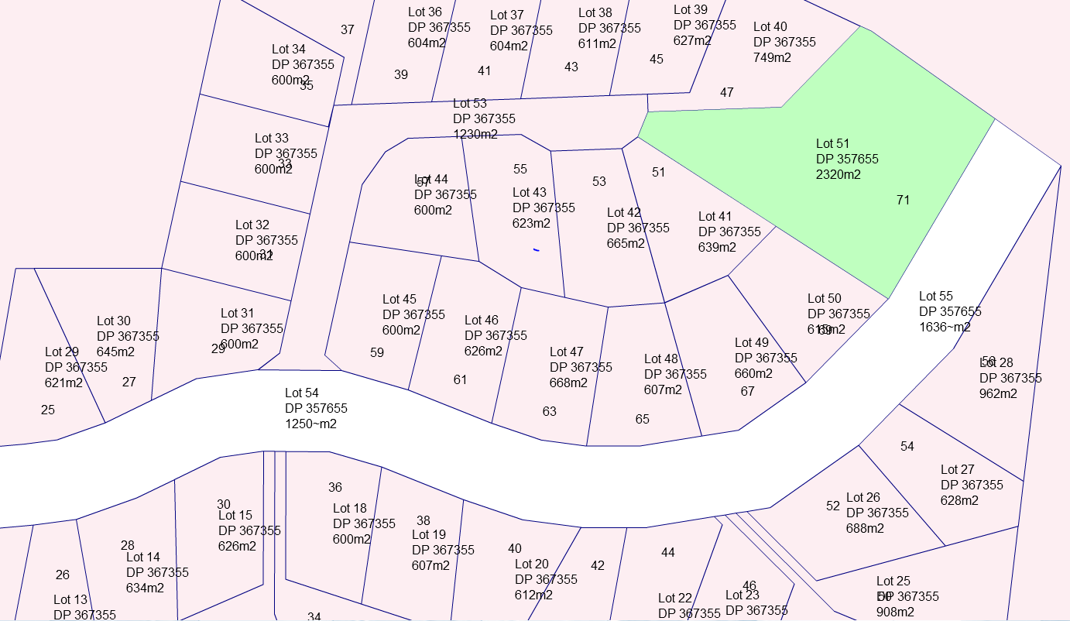
Figure 1: Location of subject allotments

5. Description of application & reasons for the consent application

The applicant seeks to remove CONO 7056308.3 from the Certificate of Titles for the 13 allotments listed in section 4 above under s221(3)(b) of the RMA.

That no Council operated water supply is currently available (except for fire fighting purposes) and no connections will be allowed without the consent of Council. All building consent applications shall make provision for water catchment and storage on-site. (All residential lots)

The application states that at the time the subdivision was granted in 2006, that water was only available for firefighting purposes. Since this time the services have been upgraded and reticulated potable water is now available to all of the named allotments.

The IAMS Development Engineer has confirmed that water is available to the boundary of each of the allotments listed in section 4 above.

Applications under s221(3)(b) of the RMA are afforded the activity status of Discretionary.

6. Section 95A(2)(b)

The applicant has not requested that the application be publicly notified.

7. Section 95A(2)(c)

There is no rule in the district plan or a national environmental standard that requires public notification of the application.

8. Pursuant to section 95D, will the activity have, or is likely to have adverse effects on the environment that are more than minor?

Effects may be in the form of increased stormwater run off into the Councils reticulated service due to increased run off from roof surfaces. However this can be addressed at building consent stage or through resource consent should Stormwater Management and/or building coverage be breached.

Other effects of the above listed allotments connecting to the Council’s reticulated potable water supply are likely positive in that the supply is secure and treated.

In conclusion, it is considered that the adverse effects of the proposed activity on the environment will be no more than minor.

9. No rule or national environmental standard precludes public notification (Section 95A(3))

10. No special circumstances exist which would lead to the conclusion that the application should be notified (Section 95A(4))

11. Recommendation pursuant to Section 95A:

That the application need not be publicly notified.

12. Are the activity’s adverse effects on any person minor or more than minor (but not less than minor)? (Section 95E)

It is not considered that there are any adverse effects on any person.

13. There are no protected customary rights group or customary marine title group affected (sections 95F and G)

14. Limited notification or non-notification.

Having considered Steps 1 – 4 in Section 95B, it is concluded that the application does not require limited notification.

15. Final Recommendations:

It is further recommended that the application be processed on a non-notified basis as there are no affected persons or affected protected customary rights groups or affected customary title groups, or a rule or national environmental standard precludes limited notification and the application does not require limited or public notification.

Report & Recommendation prepared by:

Esther-Amy Powell – Intermediate Resource Planner
Dated: 10 August 2018

16. Decision: That the above recommendation be adopted.



Louise Wilson
Team Leader – Resource Consents
(ACTING UNDER DELEGATED AUTHORITY)

Date: 10.08.2018

