
COMMENTS DUE: 30 September 2019

ENGINEERING SITE VISIT NOTES
TO RESOURCE PLANNER: |  |  | Consultant Planner Steve Sanson
ON PLANNING APPLICATION NO: |  |  | 2200170-RMASUB
APPLICANT: |  |  | Daniel James Cleary
PROPERTY LOCATION: |  |  | Lot 7, Waianga Place, Omapere 0473
FROM: |  |  | Resource Consent Engineer
Clock start date: |  |  | 17 September 2019
ASPECT |  |  | COMMENTS/ CONDITIONS REQUIRED
Site Suitability:
Topography, Stability, Erosion |  |  | The site is elevated and west facing, signs of erodible soils, and expansive clays visible in exposed cut faces. Possiable areas of cut and fill surrounding land formation shows signs of rilling, benching and movement. Proposed subdivision and building platforms are flat and smooth. Building sites will require engineering assessment for built structures
Flooding, Ground Cover, etc |  |  | Top soil looks to be 100mm thick vegetation consists of grass and exotic weeds (gorse, pampas). Soakage is poor
 |  |  | 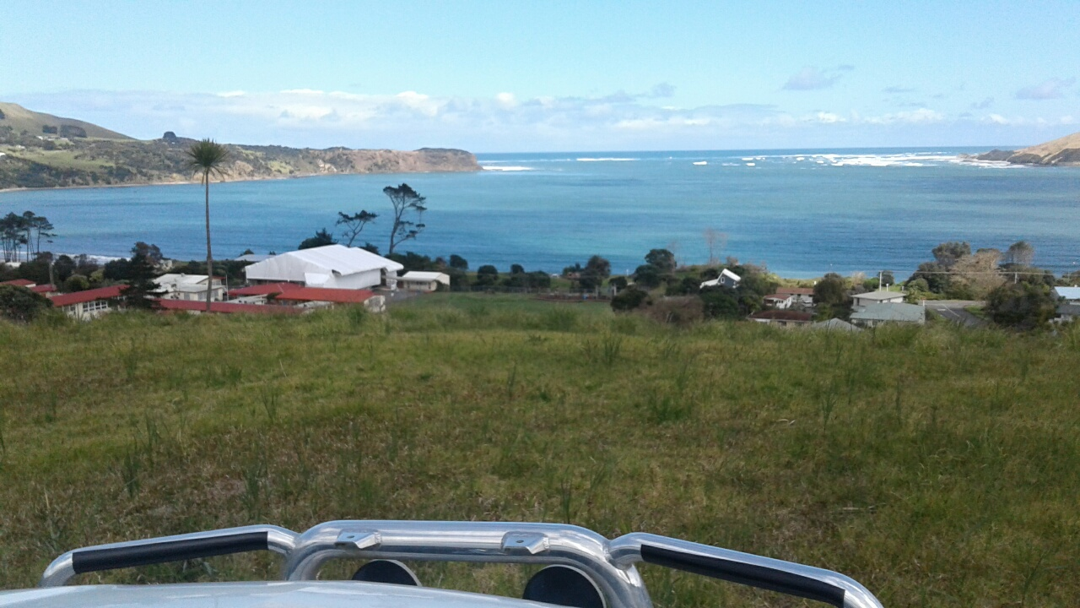
 |  |  | 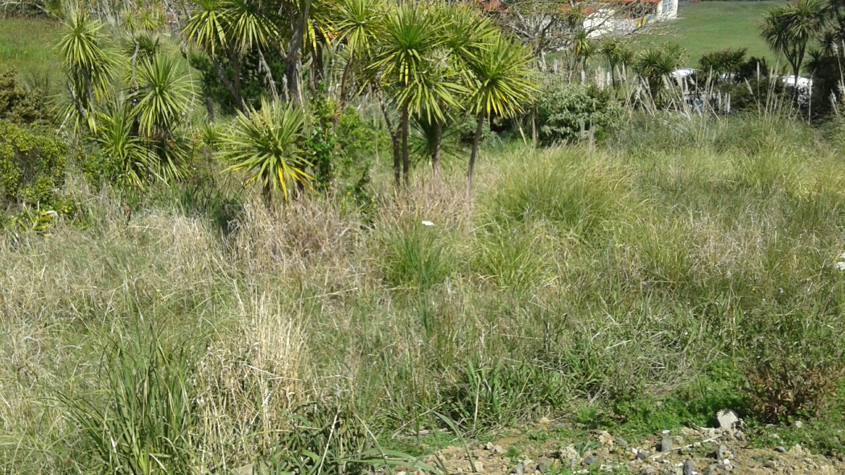
 |  |  | 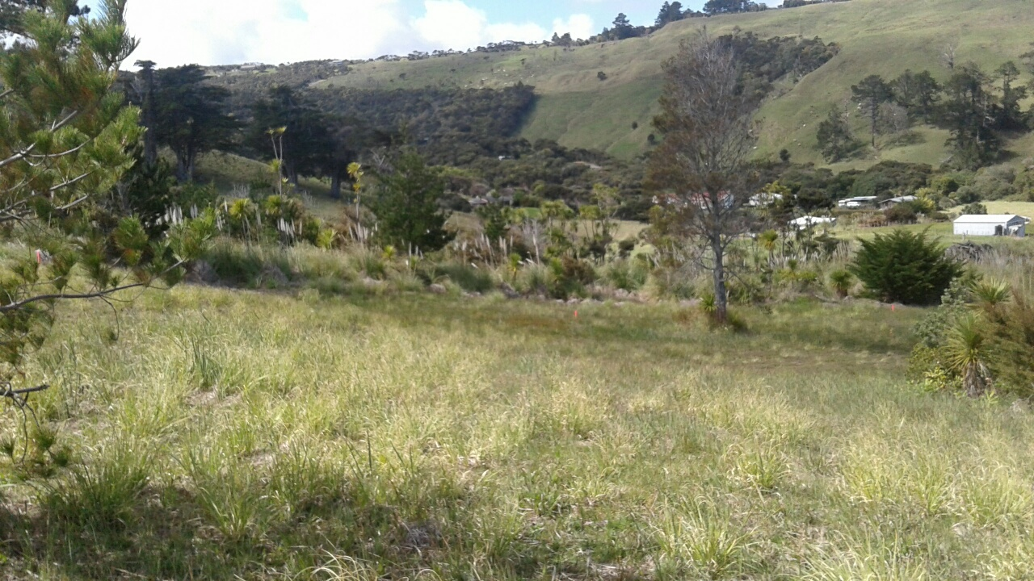
Access/Vehicle Circulation
Adequacy for Use |  |  | The current vehicle access off Waianga Place is not compliant with Engineering Standards, recommend that a turning head is constructed, development engineer has also requested, Current road is 8m wide and would be in general accordance with a Type B road which can service > 15 HE there is no street lighting or footpath.
Traffic Flows, etc |  |  | Will add another 6 users to Waianga Place taking total users above 300 traffic movements, intersection with SH12 seems adequate, however I would recommend that NZTA are consulted as school and Museum also use this road, they may require widening on seaward side of SH12
Need for upgrading adjacent areas |  |  | Upgrade required for footpath, lighting and turning head, May also be required in private road
Street Lighting
 |  |  | 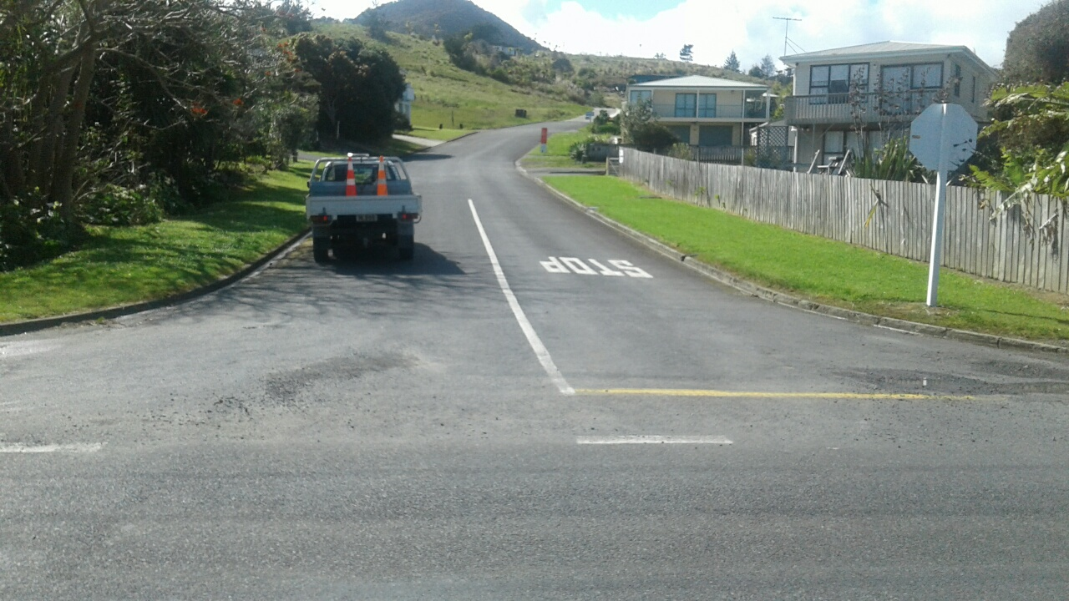
 |  |  | 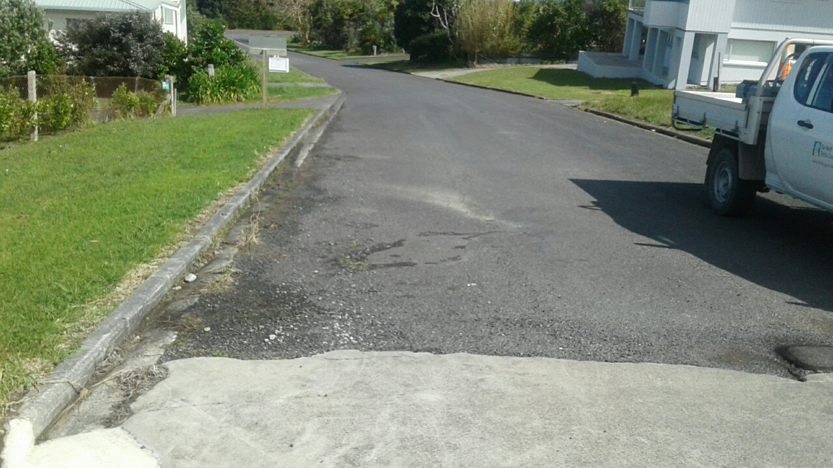
 |  |  | 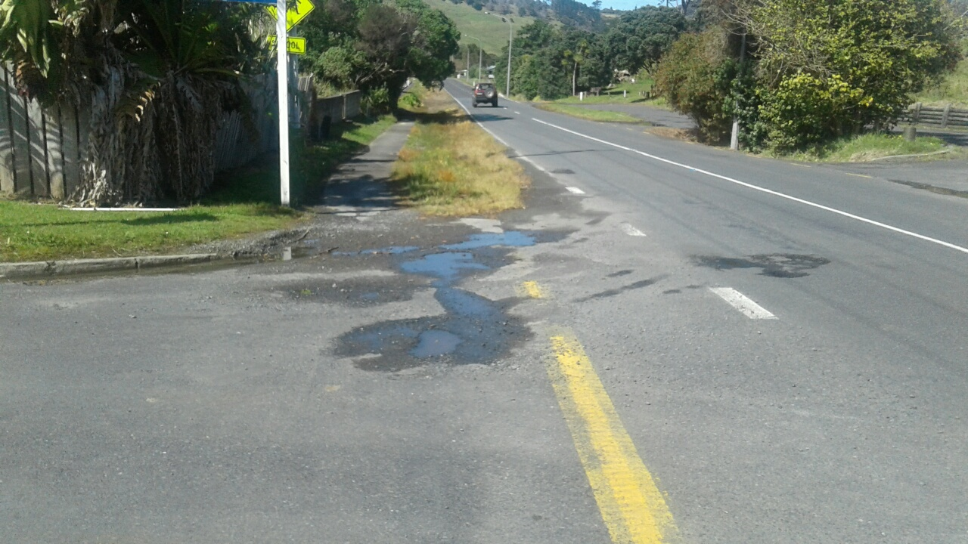
Stormwater, Wastewater & Effluent Disposal:
The site proposes to discharge into the existing stormwater disposal system, The existing attenuation was designed for the existing access road, further mitigation would be required from the development as we have flooding issues at the discharge onto SH12 drainage, this may require upgrading of current infrastructure to take increased flows.

A stormwater assessment has not been provided to identify stormwater flow paths or effects on infrastructure.
 |  |  | Sewer is to be discharged to existing public connections, suitable private easements are shown two lots to share branch drain, confirm with IAM’s connections available.
 |  |  | Water supply in Opononi comes under pressure in summer months, onsite fire fighting supply maybe required.
ASPECT |  |  | COMMENTS/ CONDITIONS REQUIRED
Earthworks:
Controls required etc |  |  | Application will require earthworks due to construction of roads, can be controlled though plan approval and supervision (will be an issue in wet weather)
Council Easements / encumbrances:
ROW, water, stormwater, waste-water, roads, drainage, power |  |  | Need to check if Easements in gross required for services in road way
Services:
Water, Irrigation, Power, Telephone |  |  | A response for power and phone not provided in application
Amenities/Reserves:
Internal Accessways |  |  | Existing private access will have over 8 users (Will need to ensure that all owners have given written permission), Existing access to lot 100 and part of lot 101 will need to widened to 5m this may be an issue due to location of services. Easements in gross for existing services?
Surfacing of Car Parks etc
 |  |  | 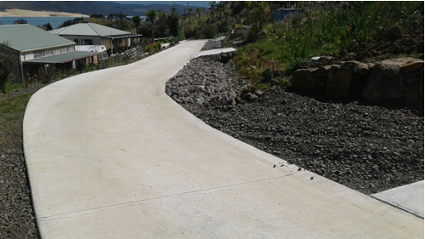
Consent Notices: |  |  | Stormwater  Water? (Depends on flows)  Buildings
Other:
NES
Proposed Conditions: |  |  | Earthworks  Plan approval (vested works turning head, footpath and lighting)  Services
Signed: |  | Date: |  |  | Mileage: |  | Time:
4 October 2019 110km from Kaikohe 3hrs

