Application No: 2200170-RMASUB
For: Lot 7, Waianga Place, Omapere 0473

24 September 2019

Daniel James Cleary
C/- Thomson Survey Ltd Att: Denis
PO Box 372
Kerikeri 0245

Dear Daniel James Cleary,

Acknowledgement of Receipt of Subdivision Application

Thank you for your application to propose a subdivision in the Coastal Residential zone to create 8 lots at Lot 7, Waianga Place, Omapere 0473. Your application was lodged on 18 September 2019. Your application reference number is 2200170-RMASUB. The application has been assigned to a Consultant Planner for processing. Should they require further information they will contact you within 20 working days.

Your feedback is important to us, so after a decision has been issued we will be sending you a brief questionnaire to assist us with improving our customer service. As council charges the actual and reasonable costs of consent processing, you may be sent either an invoice or a credit note.

Council is currently experiencing a higher than expected level of resource consent applications and has engaged a Consultant Planner to assist with assessing and processing your application. If you have any questions about your application, please email the Consultant Planner on steve@sansons.co.nz

Yours sincerely,

Sequoia Stevens
Resource Consents Department

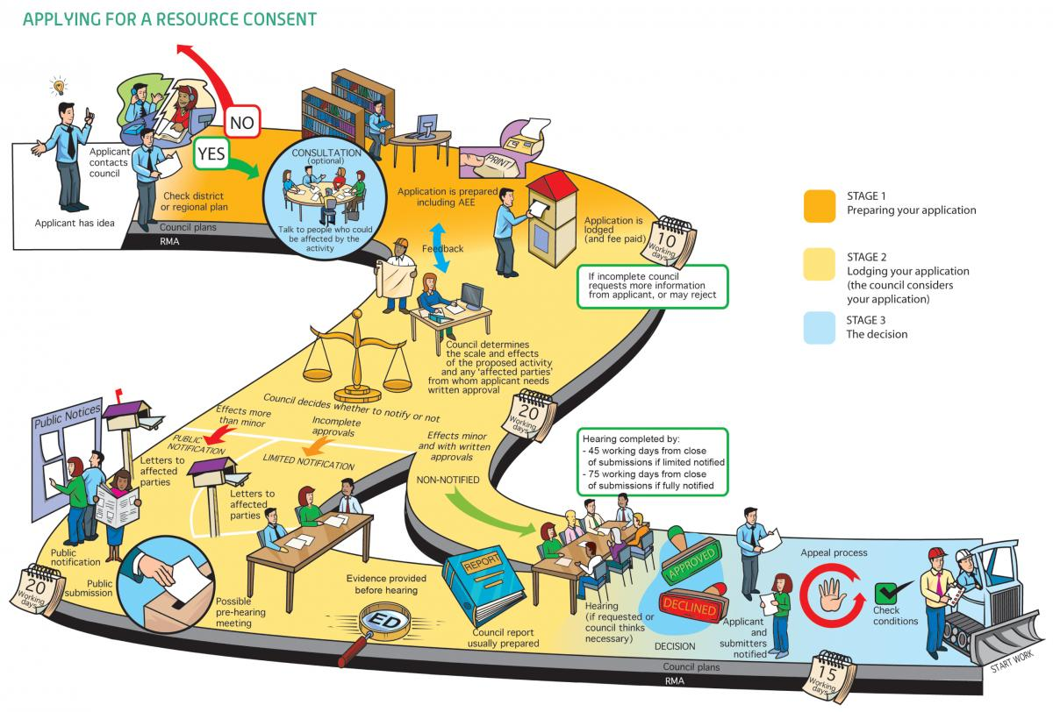Image 1: Image from "An Everyday Guide to the RMA: Applying for Resource Consent" - Ministry For the Environment, 2015

