

27 July 2020

Michelle French
C/- Totalspan Bay of Islands/Hokianga
1235B Bulls Road
RD 3
Kerikeri 0293

Reference Number: | EBC-2020-12022/0
Property Address: | Lot 7, Waianga Place, Omapere 0473
Property ID # | 3361107
Description: | Proposed Lot 8 - Unlined Heritage Barn

Dear Sir / Madam,

Further Information Request - Reminder

To date we still have not received all information previously requested to approve your building consent.

Please be aware we cannot indefinitely store applications which are not being actively progressed. Unless we either hear from you urgently or all the relevant information is received within 10 working days of the date of this letter, processing will stop and the application will be refused.

If there are valid reasons why this information cannot be provided without delay, please do not hesitate to contact us urgently. We may be able to assist or arrange an extension of time.

Your cooperation in providing all the information at the same time will avoid unnecessary delays.

If you have any questions please contact the Building Team on 0800 920 029 or 09 401 5200.

Yours faithfully,

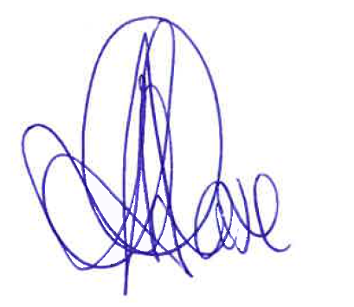

Building Team
District Services

