Application No: 2200253-RMASUB
For: Lot 2, Newton Road, Omapere 0473

11 November 2019

Zhann Tracey
C/- Thomson Survey Ltd
PO Box 372
Kerikeri 0245

Dear Zhann Tracey,

Acknowledgement of Receipt of Subdivision Application

Thank you for your application to proposed subdivision at Lot 2, Newton Road, Omapere 0473. Your application was lodged on 6 November 2019. Your application reference number is 2200253-RMASUB. The application has been assigned to a Consultant Planner for processing. Should they require further information they will contact you within 20 working days.

Your feedback is important to us, so after a decision has been issued we will be sending you a brief questionnaire to assist us with improving our customer service. As council charges the actual and reasonable costs of consent processing, you may be sent either an invoice or a credit note.

Council is currently experiencing a higher than expected level of resource consent applications and has engaged a Consultant Planner to assist with assessing and processing your application. If you have any questions about your application, please email the Consultant Planner on Alvin.j@stellarprojects.co.nz

Yours sincerely,

Sequoia Stevens
Resource Consents Department

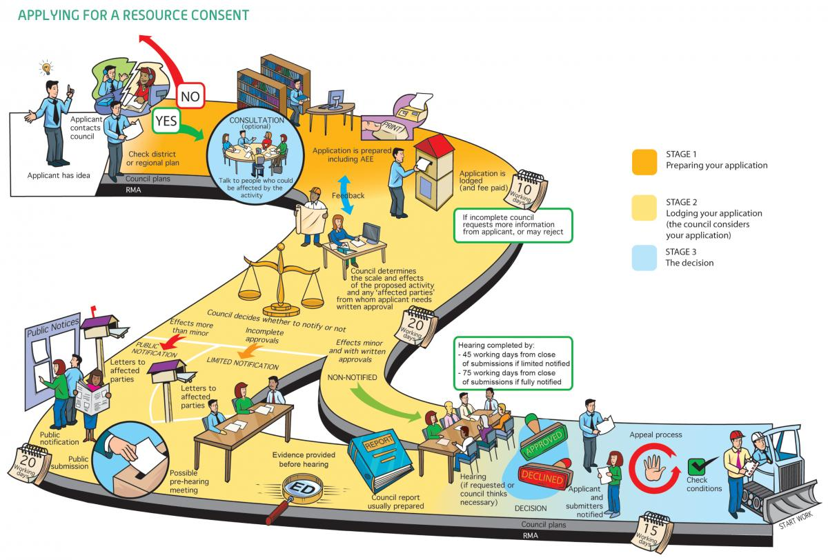Image 1: Image from "An Everyday Guide to the RMA: Applying for Resource Consent" - Ministry For the Environment, 2015

